After Installing: Configuring With GPRM
A Windows installation of DerbyNet can use the same Access database as Grand Prix Race Manager (GPRM); this allows web-based access to the data while still using GPRM. This is accomplished by defining the GPRM database as an “Open Data Base Connectivity” (ODBC) data source.
Note that you must update the ODBC data source whenever you change databases in GPRM.

Define an ODBC Data Source Name
In “Control Panel,” “Administrative Tools,” find the “Data Sources (ODBC)” management console. Choose the “System DSN” tab, and click the “Add…” button.

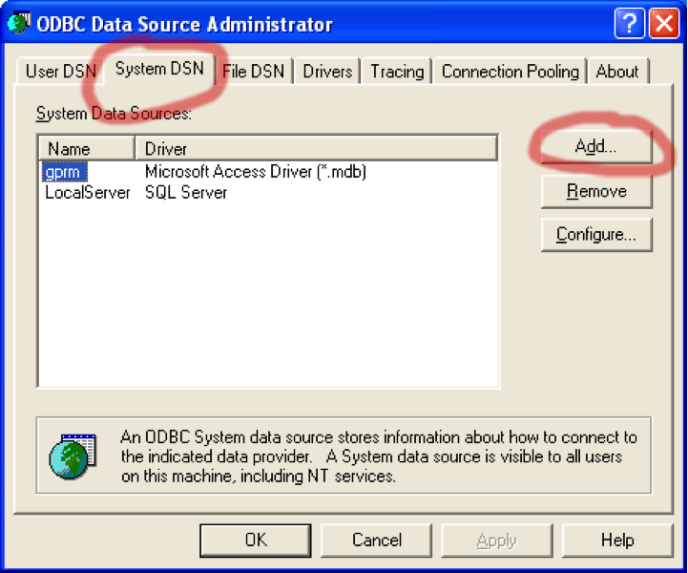
In the “Create New Data Source” dialog that appears, select “Microsoft Access Driver (*.mdb)” and click “Finish.”
Note: In some 64-bit versions of Windows (notably Windows 7, at least), the driver for Microsoft Access is available only in the 32-bit version of the ODBC Data Sources Administrator control panel. If you do not see an entry for “Microsoft Access Driver (*.mdb)” or similar, close the control panel and instead open C:\Windows\SysWOW64\odbcad32.exe. See http://support.microsoft.com/kb/2721825/EN-US.
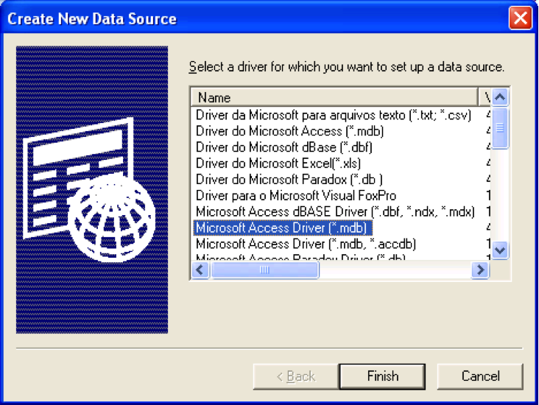
Next you’ll see the “ODBC Microsoft Access Setup” dialog. Enter “gprm” in the Data Source Name field (this is the name the scripts expect), and click the “Select…” button.
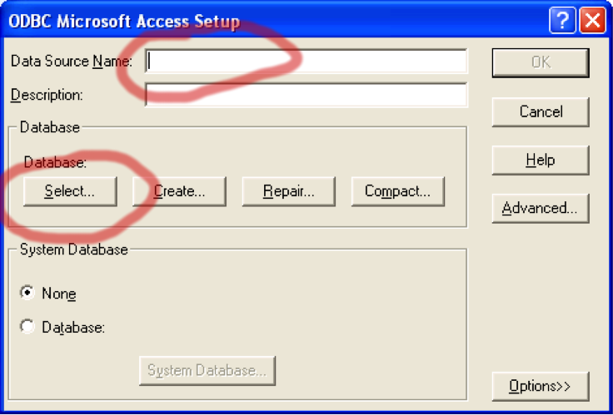
In the “Select Database” dialog, you have to select the actual database file you’re using for GPRM. By default, the path to this file is under “My Documents”, “Lisano Enterprises”, “GrandPrix Race Manager”, “Data” (at least in version 9 of GPRM).
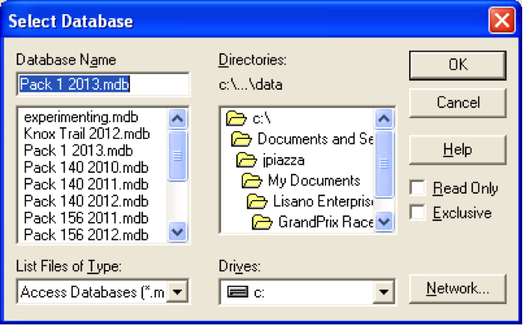
Changing the data source (as opposed to adding a new one) is similar; click the “Configure…” button instead of “Add…” from the ODBC Data Source Administrator window, and just select a new database file.

Set Up Database for DerbyNet

Create Database Configuration File
If you've just installed DerbyNet, you can visit http://localhost, which should redirect to the database set-up page. There you should see that you don't yet have a configuration file:
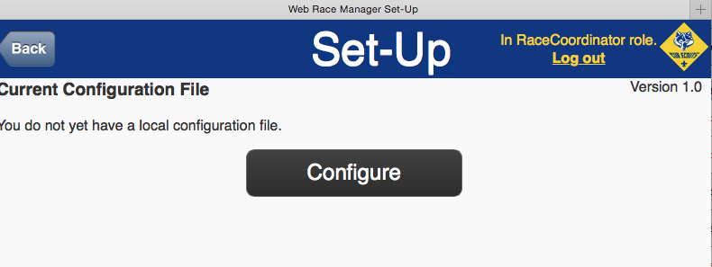
If you've already done this once, and now you want to switch to a different configuration, just click on the “Database” button from the main menu while logged in as the race coordinator. Alternatively, if you delete the configuration files in the local directory, DerbyNet will once again be in a just-installed state.
Clicking the Configure button lets you enter a database connection string, plus a database user name and password. (Some kinds of database have user names; others don't.)
For a database exposed through ODBC, click on “ODBC Data Source” and just enter the name of the ODBC data source name (DSN), e.g., “gprm.”
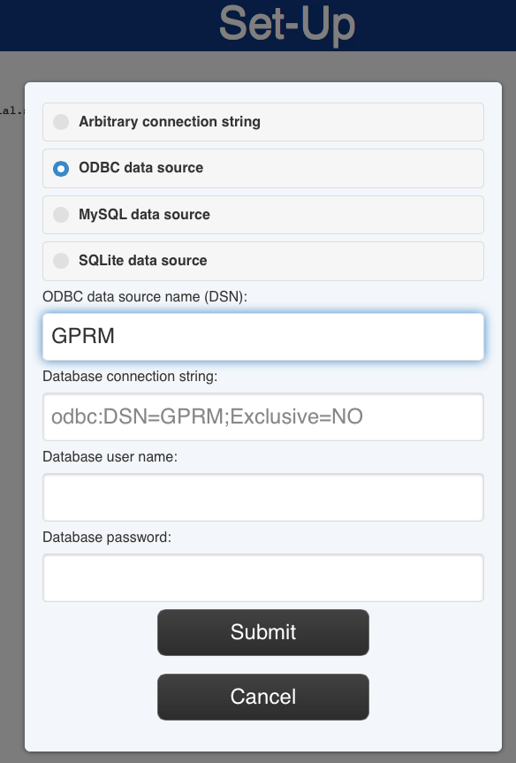
The connection string will get constructed as you type, and should look like:
odbc:DSN=gprm;Exclusive=NO
where 'gprm' is the name of the ODBC data source name you created. You can leave the user name and password fields blank. When you click the “Submit” button, you should see a confirmation that you correctly configured the database:

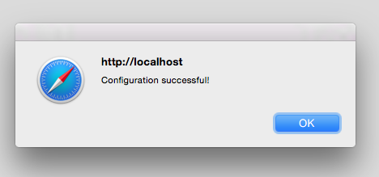
Do Not Initialize the Database Schema
Assuming your ODBC data source is an existing GPRM database, you should probably not initialize the schema – doing so will erase all the data that's in the database. If you haven't yet put any data in the database, then the schema initialization should have no effect.

Maybe Update the Database Schema
Similarly, the DerbyNet software should work well without the need to update the schema. (A schema update, as opposed to schema initialization, should preserve existing data in the database. However, DerbyNet should also function without the update.)

